**Week 5:**

**Creating Microservices for account and loan:**

**1.Create Account Service:**

**Model: Account.java:**

@Entity

public class Account {

@Id

@GeneratedValue

private Long id;

private String name;

private String email;

private Double balance;

}

**Repository: AccountRepository.java:**

public interface AccountRepository extends JpaRepository<Account, Long> {}

**Controller: AccountController.java:**

@RestController

@RequestMapping("/accounts")

public class AccountController {

@Autowired

private AccountRepository repo;

@PostMapping

public Account create(@RequestBody Account account) {

return repo.save(account);

}

@GetMapping("/{id}")

public Account getAccount(@PathVariable Long id) {

return repo.findById(id).orElse(null);

}

}

**application.yml:**

server:

port: 8081

spring:

datasource:

url: jdbc:h2:mem:accountdb

driverClassName: org.h2.Driver

username: sa

password:

jpa:

hibernate:

ddl-auto: update

show-sql: true

2. **Create Loan Service:**

**Model: Loan.java:**

@Entity

public class Loan {

@Id

@GeneratedValue

private Long id;

private Long accountId;

private Double amount;

private int duration; // months

}

**Repository: LoanRepository.java:**

public interface LoanRepository extends JpaRepository<Loan, Long> {

List<Loan> findByAccountId(Long accountId);

}

**Controller: LoanController.java:**

@RestController

@RequestMapping("/loans")

public class LoanController {

@Autowired

private LoanRepository repo;

@PostMapping

public Loan create(@RequestBody Loan loan) {

return repo.save(loan);

}

@GetMapping("/account/{accountId}")

public List<Loan> getLoans(@PathVariable Long accountId) {

return repo.findByAccountId(accountId);

}

}

**application.yml:**

server:

port: 8082

spring:

datasource:

url: jdbc:h2:mem:loandb

driverClassName: org.h2.Driver

username: sa

password:

jpa:

hibernate:

ddl-auto: update

show-sql: true

**OUTPUTS:**

**POST /accounts:**

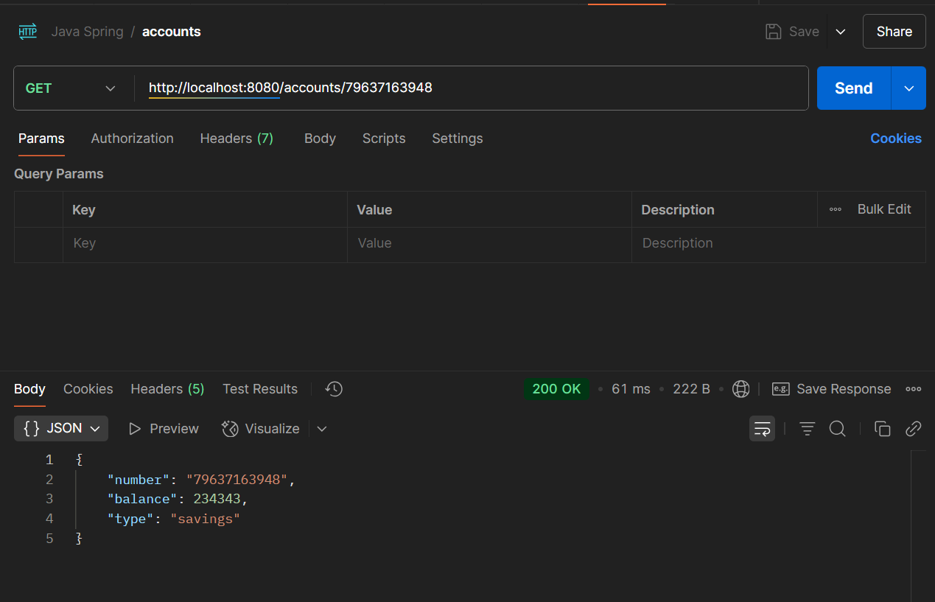

**GET /accounts/{id}:**

**POST /loans:**

**GET /loans/account/{accountId}**

